Edgar Arroyo

7/4/2024

Modul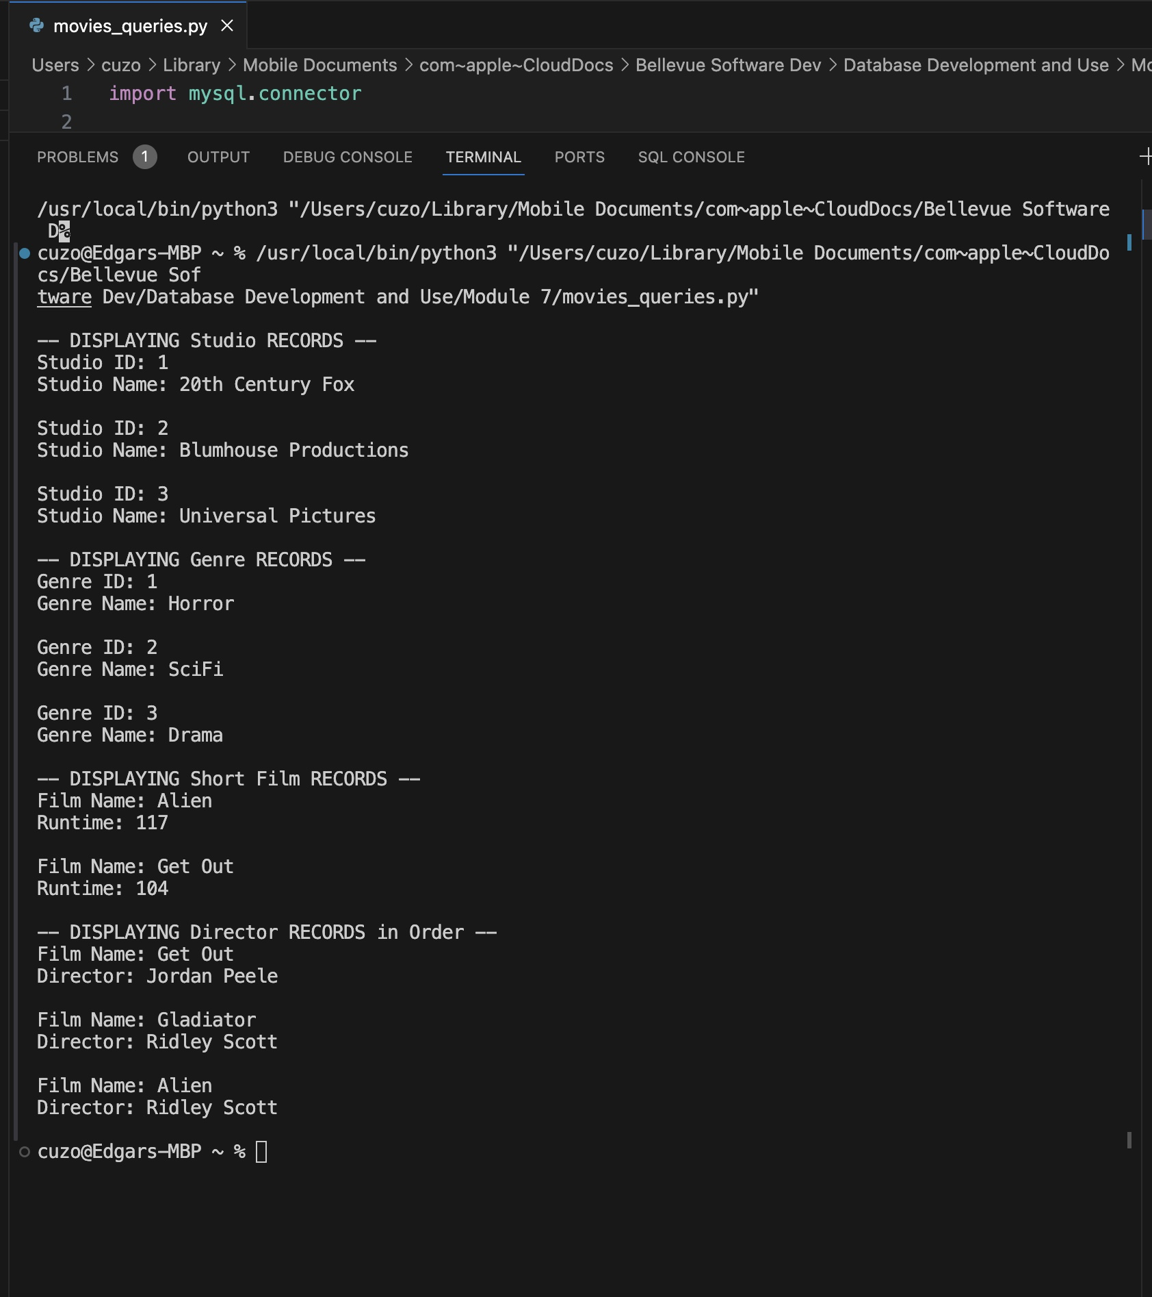e 7 Assignment: Table Queries